**­­­Republic of the Philippines**

**UNIVERSITY OF SOUTHEASTERN PHILIPPINES**

**COLLEGE OF INFORMATION AND COMPUTING**

Iñigo St., Obrero, Davao City, 8000



ORGANIZATION INFORMATION SYSTEM

Analysis, Design and Implementation

BSIT 2A

***Developers:***

*Aguilar, Aimee Grace D.*

*Antalan, Akela Paulene B.*

*Valenzona, Shekinah Jane E.*

JUNE 2020

**TABLE OF CONTENTS**

1. **Introduction ……………………………….. 2**
2. **Website Information**
3. **Content Sections ……………………………….. 3**
4. **Target Audience ……………………………….. 3**
5. **Objectives ……………………………….. 3**
6. **Technical Specifications ……………………………….. 4**
7. **Sitemap ……………………………….. 5**
8. **Screenshots ……………………………….. 5**
9. **Curriculum Vitae ……………………………….. 12**
10. **INTRODUCTION**

Stakeholders considered records, data and information as essential resources because it strengthened the success of every organization. However, it needs an excessive effort to be able to collect, store, access and monitor such things, especially if the organization is using the traditional way of storing data where it is done manually on the papers. This becomes one of the major complications faced by some of the organizations about data management particularly with those who have larger scale. Also the security is highly at risk, when the leaking of information or an unexpected natural phenomena might happened.

Problems in managing and monitoring events of every organization also emerged if the data and information are not stored properly and securely. With that, the team proposed the Organization Information System (OIS) as a solution to address all the aforementioned problems.

OIS is an automated collecting, storing, accessing, managing and monitoring of data on a single platform. The system was solely built to lessen the burden of data storing by business organizations and companies. The system has staff management, financial management, events management, monitoring management and reports.

The system has the features of adding, updating, deleting and viewing functions for each management. Where it can record the staffs, activities and basic cash flow that includes the income and expenses of the organization. Another feature of the system is the posting of all the accomplished activities within the system. Staffs can upload photos, accomplishment reports, attendance of events and other pertinent activities.

Moreover, there is an existing system like the HoneyBook is an all-in-one business management platform and company management system. HoneyBook helps creative professionals in the events industry get organized, elevate their brand, and deliver the digital booking and payment experience their clients expect. The platform handles pesky, time-consuming processes and gets them booked and paid faster with beautiful digital proposals, e-signatures, and online payments & reminders. The clients who gave HoneyBook a negative review grumbled that the product contains system bugs and that a few messages they send end up on their customer's garbage envelopes. Some referenced that it takes a few days for instalments from their customers to be kept on their financial balances. Others added that it needs to incorporate some fields on its receipt.

1. **WEBSITE INFORMATION**
2. Content Sections

* Welcome Page: Shows the logo and tagline of the organization. User can also see the latest news in the organization. It is also the page where the user can log in or choose to sign up.
* Latest News: Displays the latest news in the company.
* Dashboard: Displays the links for event management, staff management, financial management, organizations reports latest news, profile and active users. It is also the page where the user can log out.
* Manage Events: Also known as event management. Users can add, view, edit and delete information about the events of the organization.
* Manage Staff: Also known as staff management. Users can add, view, edit and delete information about the staffs of the organization.
* Manage Finances: Users can add, view, edit and delete information about the finances of the organization.
* Manage Report: Users can add, view, edit and delete information about the reports or latest news of the organization. Users can also upload the accomplishment reports and pictures of the company.
* Profile: The user can view and edit his/her information
* Users: Displays the over-all registered users in the system

1. Target Audience

Business organizations and company located in Davao City area.

c. Objectives

• Build an automated collecting, storing, accessing, managing and monitoring of data.

• Generate a single platform for all the transactions particularly staff management, financial management, events management, monitoring management and reports management of a particular organization.

• Produce a friendly-user system that helps to improve the organization’s storing of data.

• Improve the updates of the organizations’ data to ensure reliability for monitoring.

• To generate a system that only authorized users can modify the data.

1. Technical Specifications

-needed to search

- tools used to design, build and deploy the site

- php and html language

- MySql Database

- Hosting

- domain

- minimum browser

- recommended browser

- plug-ins needed

- search please

1. Technical Specifications

The OIS was built with PHP version 7 and Visual Studio Code, an open-source web scripting language. Data will be stored in a MySQL database, also open source. The user interface was developed in HTML5 and JavaScript. The system was able to run on any web server that supports PHP 7 and has a MySQL database. However the system is recommended for desktop browsers.

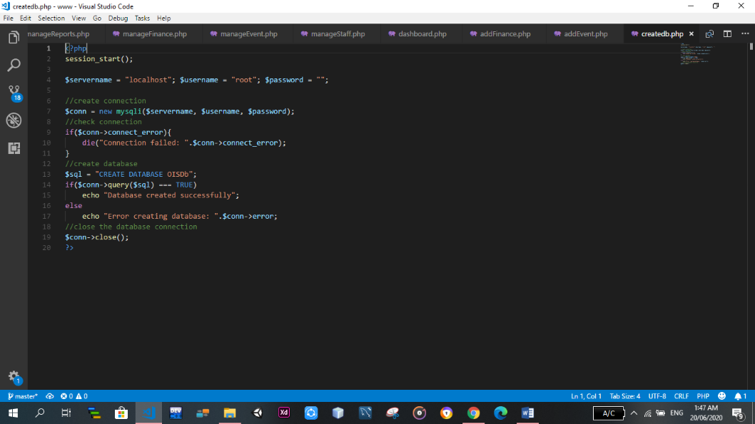

\

1. Sitemap

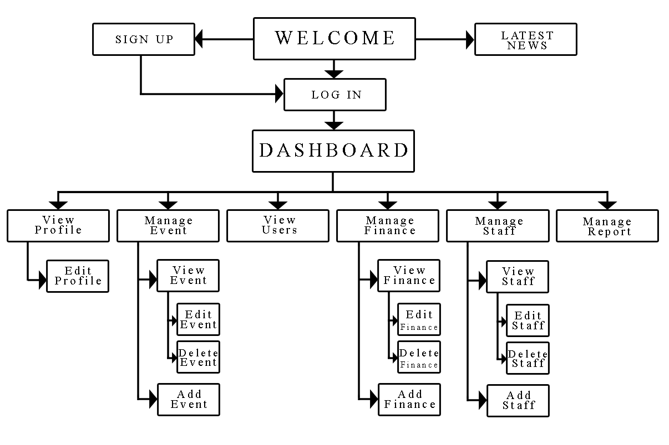

f. Screenshots

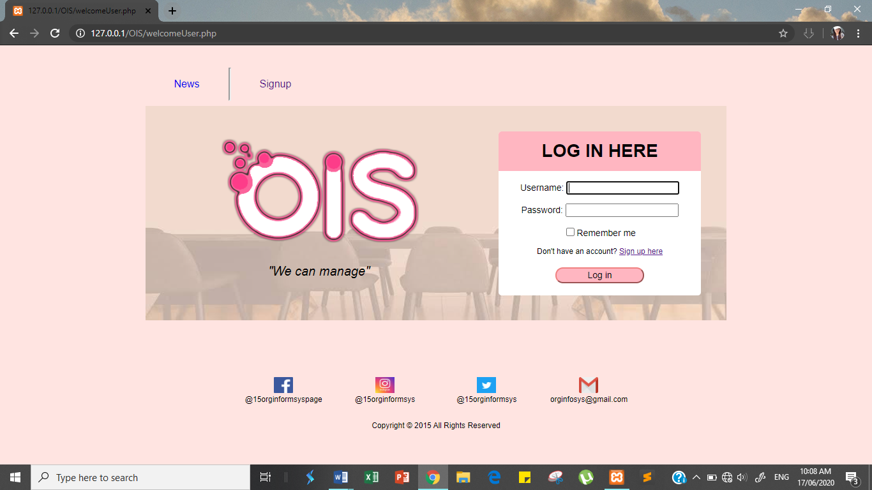

*Figure 1. Welcome page*

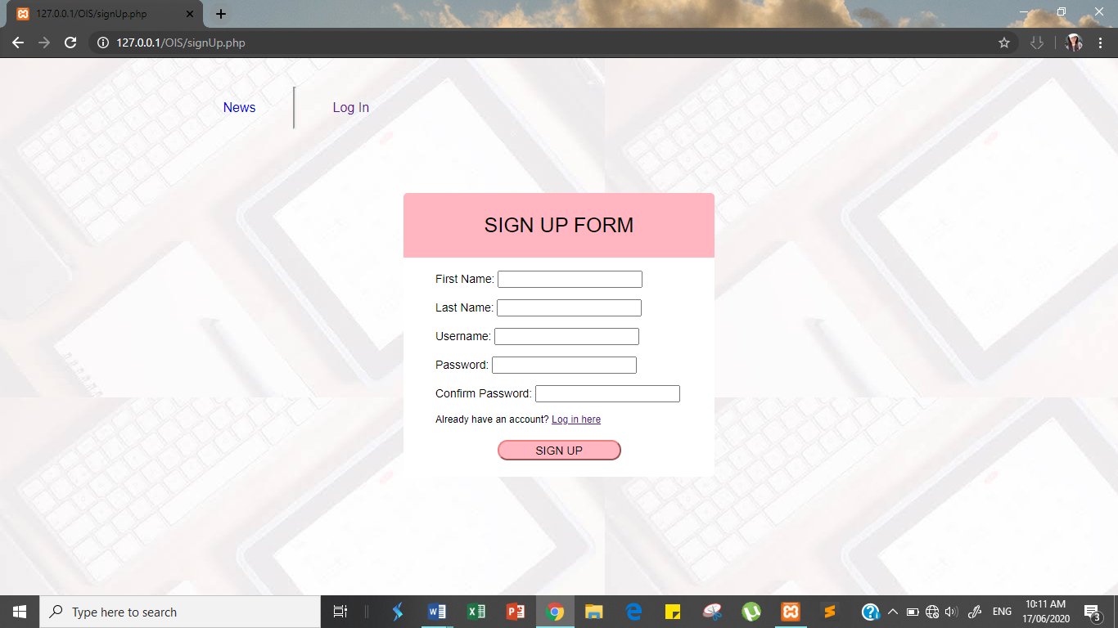

*Figure 2. Sign up page*

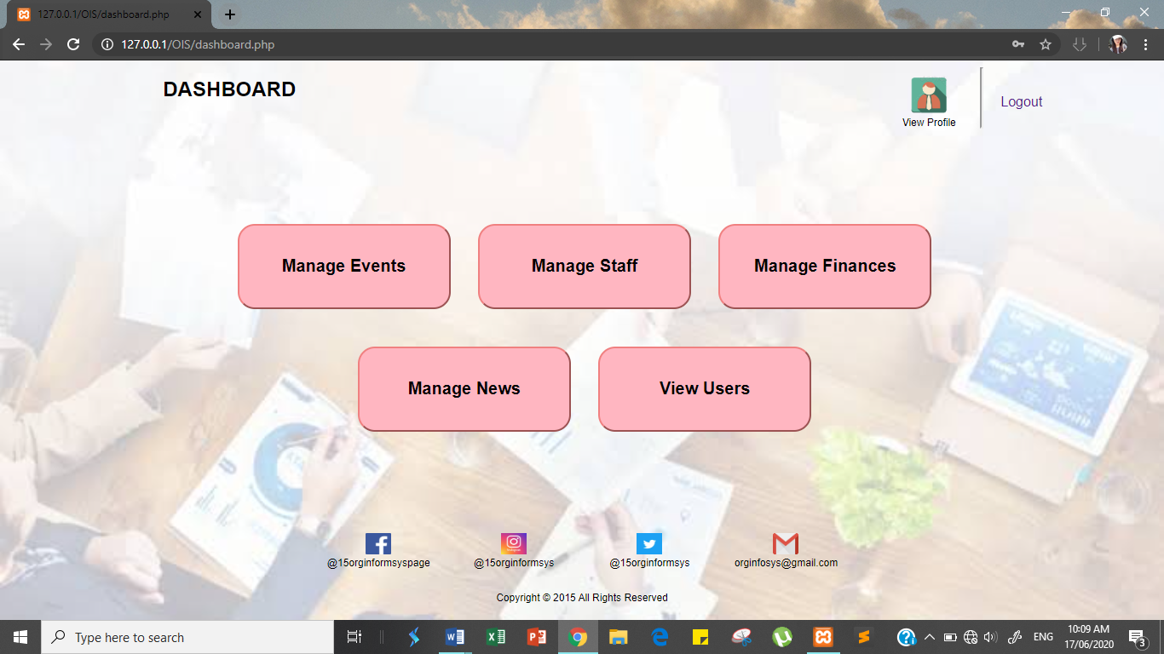

*Figure 3. Dashboard page*

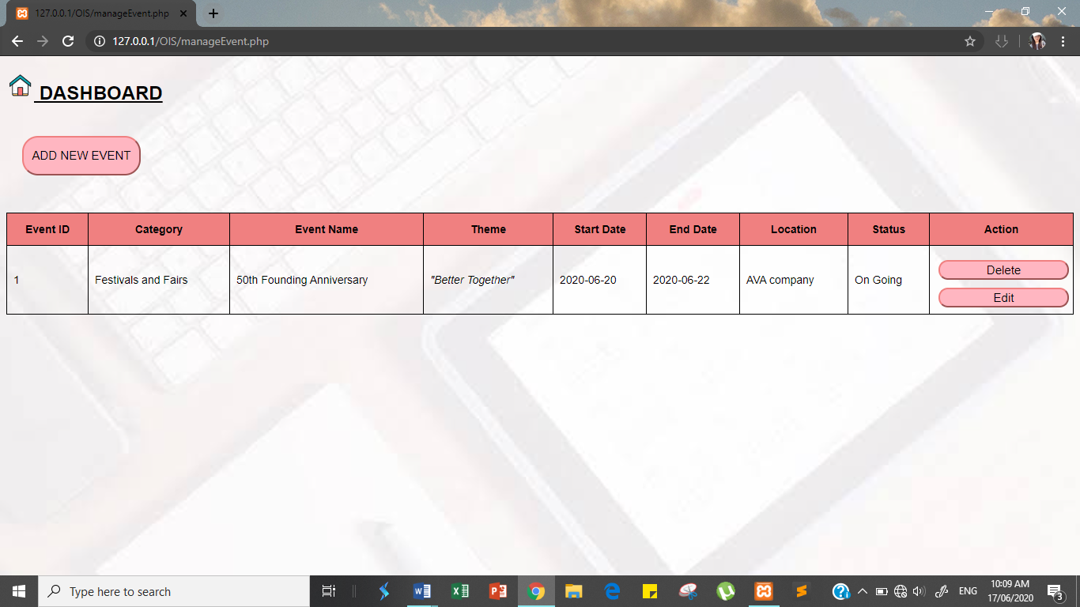

*Figure 4. Manage Event page*

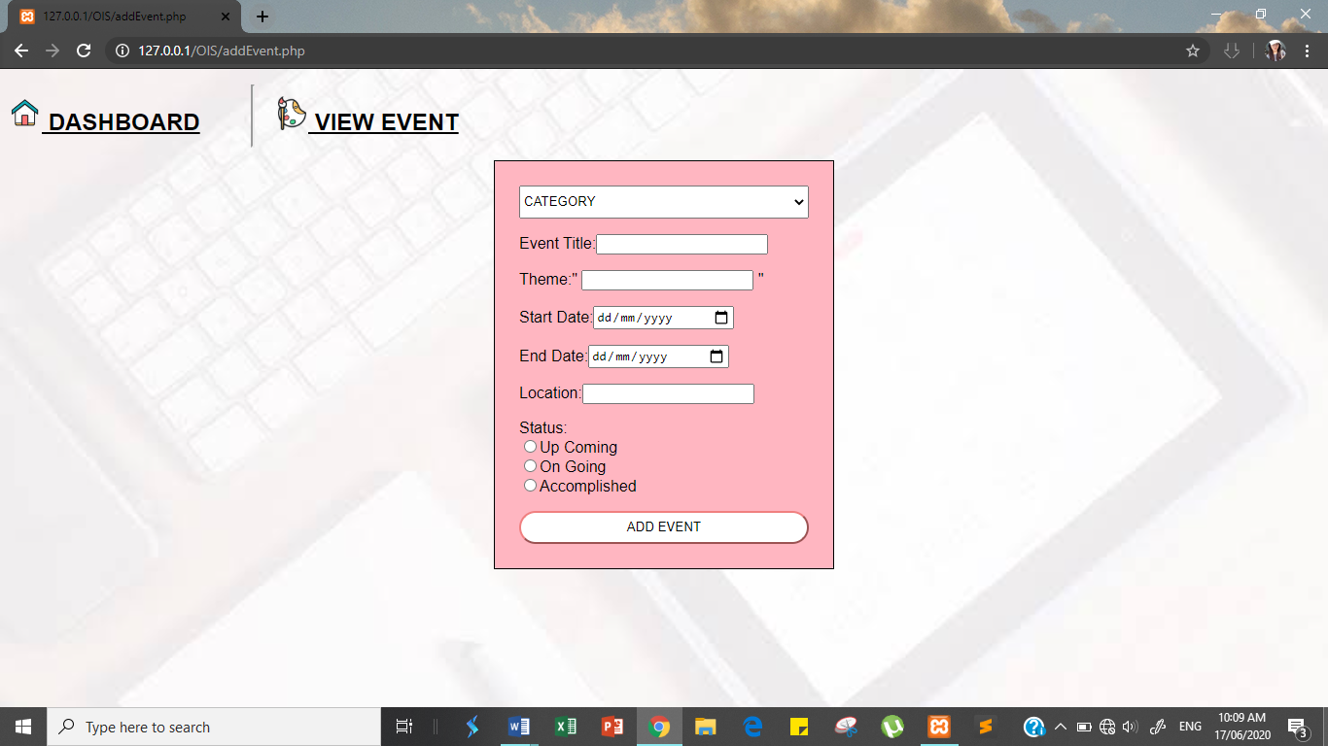

*Figure 5. Add Event page*

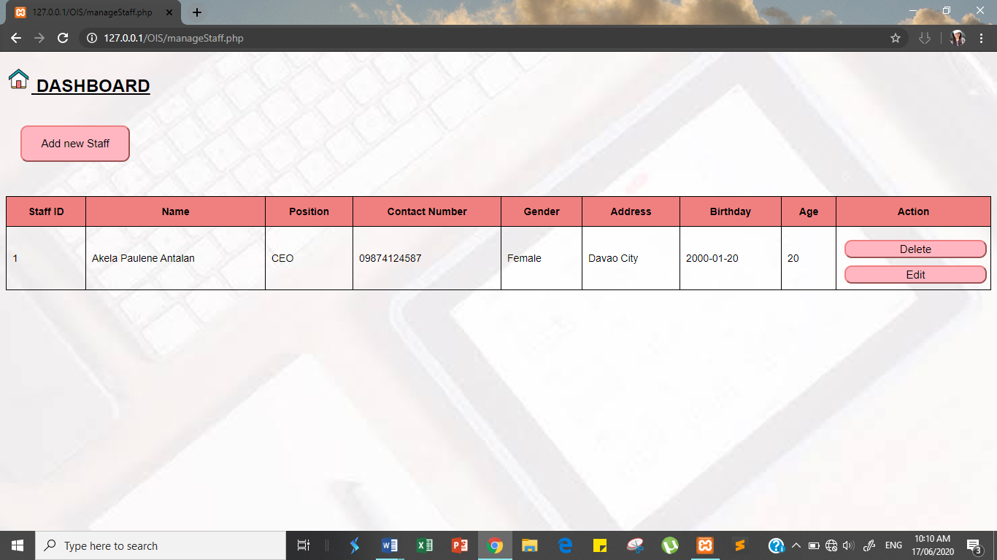

*Figure 6. Manage Staff page*

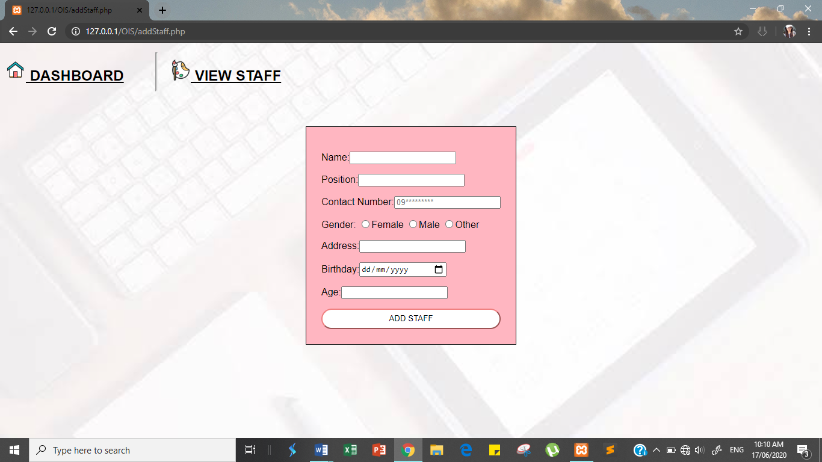

*Figure 7. Add Staff page*

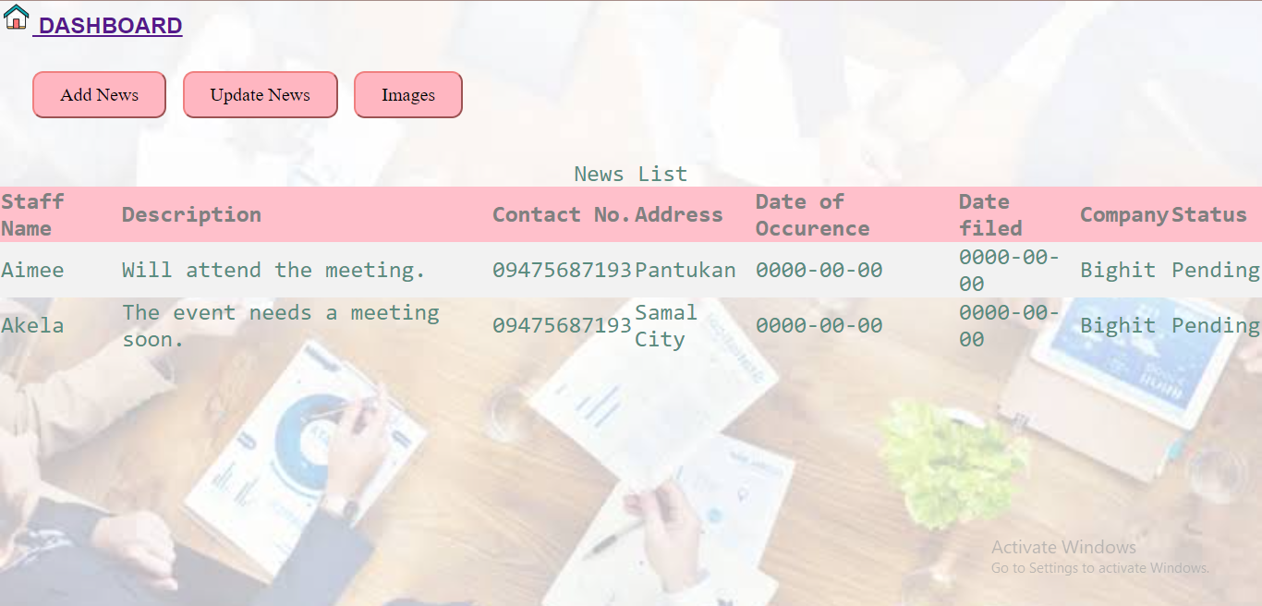

*Figure 8. Manage News page*

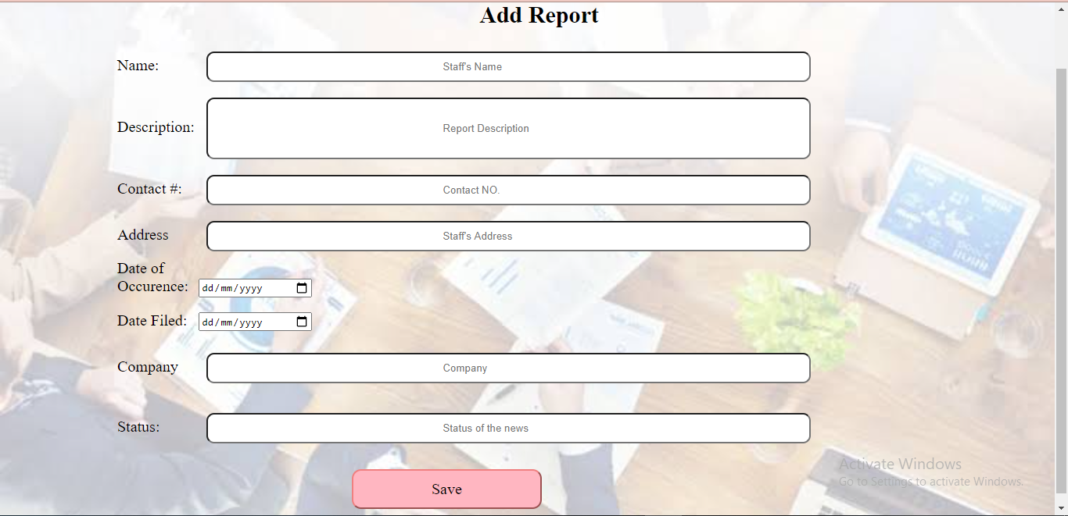

*Figure 9. Add News page*

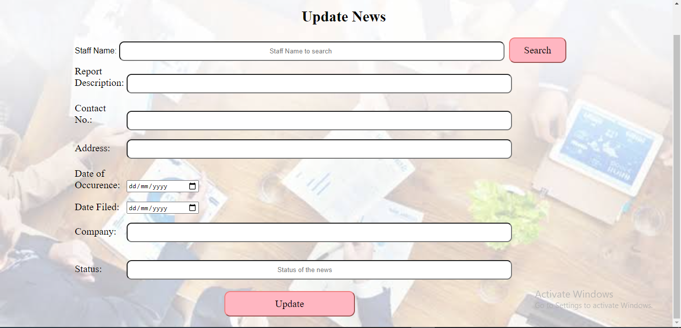

*Figure 10. Update News page*

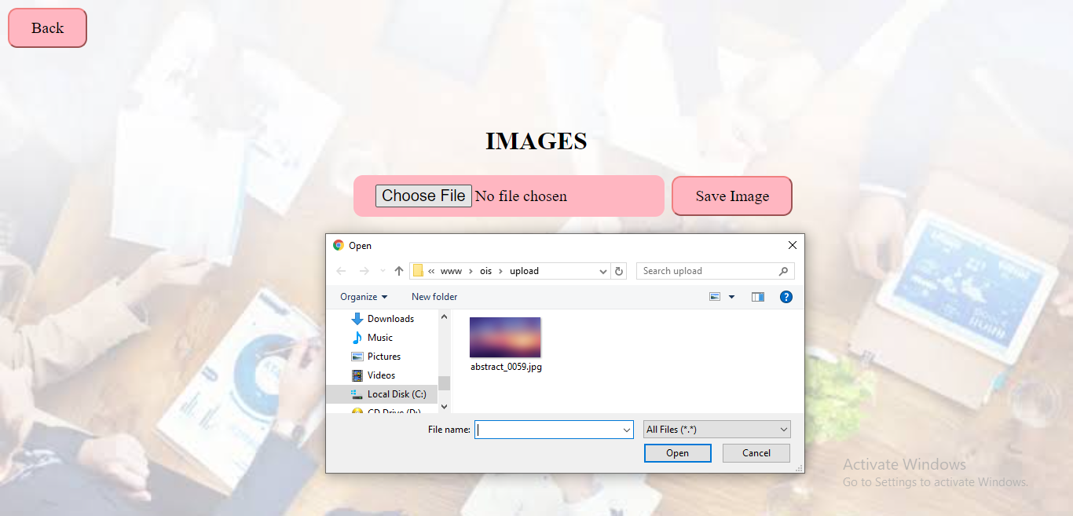

*Figure 11. Image page*

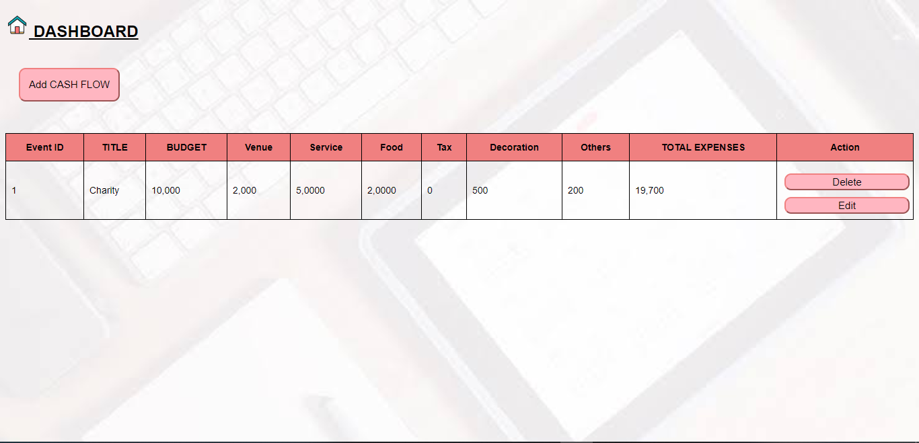

*Figure 12.Manage Finance page*

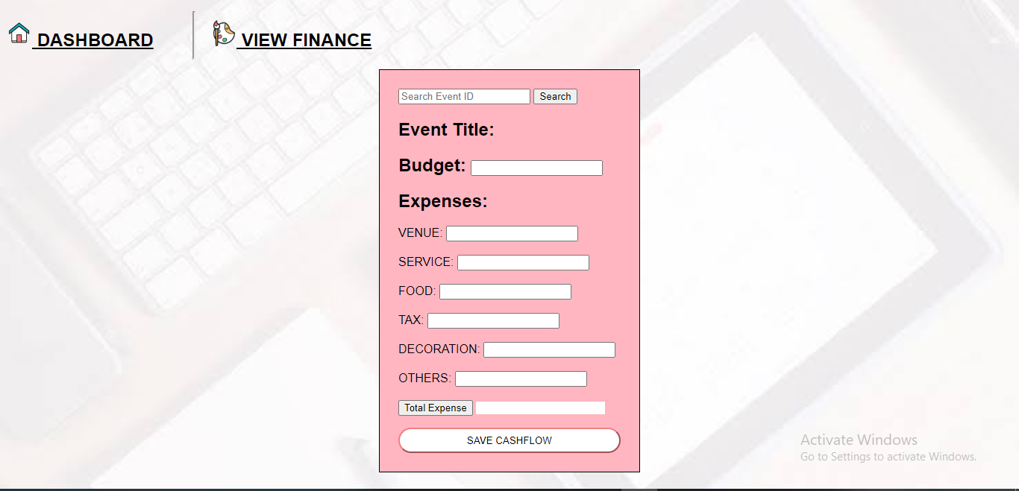

*Figure 13.Add Cash Flow page*

1. **Curriculum Vitae**



**AIMEE GRACE DAJAS AGUILAR**

Purok 2, Bongbong, Pantukan, Davao de Oro 8809

agdaguilar@usep.edu.ph

+639151826052

­­­­­­­­

|  |  |  |
| --- | --- | --- |
|  | Name of School | Year Graduated |
| College: | UNIVERSITY OF SOUTHEASTERN PHILIPPINES  Iñigo St., Obrero, Davao City 8000  Information Technology | 2018 – Present |
| Senior High School: | UNIVERSITY OF MINDANAO  Bolton St., Davao City 8000  Accountancy Business Management | 2016 – 2018 |
| ­­Junior High School: | PANTUKAN NATIONAL HIGH SCHOOL  Bonifacio St., Kingking, Pantukan,  Davao de Oro 8809 | 2012 – 2016 |
| Elementary School: | BONGBONG ELEMENTARY SCHOOL  Bongbong, Pantukan, Davao de Oro 8809 | 2006 – 2012 |

**PERSONAL INFORMATION**

Birthday: June 9, 2000S

Father: Alexander V. Aguilar

Mother: Imelda D. Aguilar



**AKELA PAULENE B. ANTALAN**

Mambago-A, Island Garden City of Samal

apbantalan@usep.edu.ph

+639475687193

­­­­­­­­

|  |  |  |
| --- | --- | --- |
|  | Name of School | Year Graduated |
| College: | UNIVERSITY OF SOUTHEASTERN PHILIPPINES  Iñigo St., Obrero, Davao City 8000  Information Technology | 2018 – Present |
| Senior High School: | UNIVERSITY OF MINDANAO  Peñaplata, Island Garden City of Samal  General Academic Strand | 2016 – 2018 |
| ­­Junior High School: | ASSUMPTION ACADEMY OF  PEÑAPLATA INC.  Peñaplata, Island Garden City of Samal | 2012 – 2016 |
| Elementary School: | S.I.R. Elementary School  S.I.R. Matina, Davao City | 2006 – 2012 |

**PERSONAL INFORMATION**

Birthday: January 20, 2000

Father: Clovis Anthony L. Antalan

Mother: Marissa B. Antalan



**SHEKINAH JANE EBARLE VALENZONA**

Purok 3, Tagpore, Panabo City

sjevalenzona@usep.edu.ph­

+639564134455 / +639774232417

­­­­­­­­

|  |  |  |
| --- | --- | --- |
|  | Name of School | Year Graduated |
| College: | UNIVERSITY OF SOUTHEASTERN PHILIPPINES  Iñigo St., Obrero, Davao City 8000  Information Technology | 2018 – Present |
| Senior High School: | JOSE MARIA COLLEGE  Philippine-Japan Friendship High way, Catitipan, Davao City 8000  Accountancy Business Management | 2016 – 2018 |
| ­­Junior High School: | A.L. Navarro National High School  Lasang, Davao City 8000 | 2012 – 2016 |
| Elementary School: | TAGPORE ELEMENETARY SCHOOL  Purok 3, Tagpore, Panabo City | 2006 – 2012 |

**PERSONAL INFORMATION**

Birthday: October 28, 1999

Father: Earl Jone Valenzona

Mother: Mary Jane E. Valenzona